NSP Working Widget Guide

Forms
- Field Formatting
  - Add one layout widget per field
  - Make the CSS Class “form-group”
  - When form is created, every field should be wrapped in it’s own layout
- Form Fields
  - Date Inputs
    - Add textbox
    - Add CSS Class: “dateformat”
  - Phone Numbers
    - Add textbox
    - Add CSS Class: “phoneFormat”
- Form Widgets
  - First Place a layout widget on the page called “form-layout”
  - This has a section for the title and for the form
    - For the title, if applicable, add the content widget called Section Title
    - For the form, add the form widget and select the form

Content Widgets
- Help Tiles (FAQ Widget) – Product Landing Page (/product-landing-page)
  - Add a “section” layout widget, no class modification needed.
  - If applicable, add a “Section Title” content widget.
  - Add the FAQ widget, in the list settings, change the template to accordion.

- Featured Video/Image – Product Landing Page (/product-landing-page)
  - 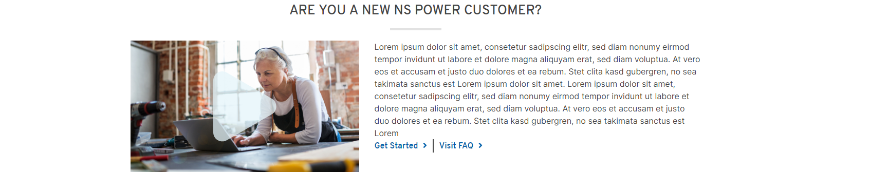
  - Add widget to the page with content, no extra layouts needed.
- Tile Cards – Product Landing Page (/product-landing-page)
  - 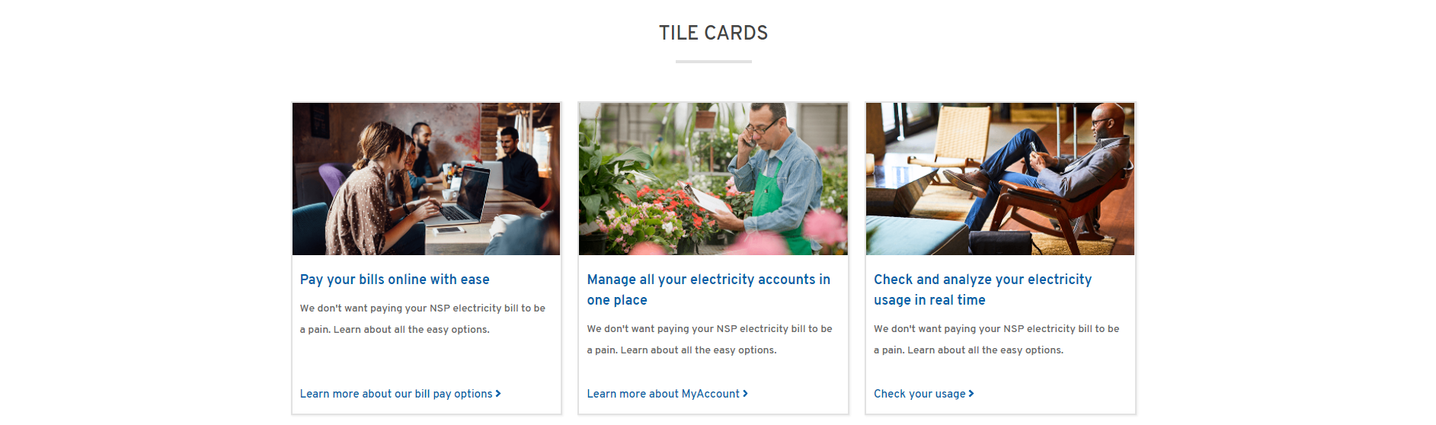
  - Add layout widget “white-background-layout” or “blue-background-layout”
  - If applicable, add a “Section Title” content widget
  - Inside of the background color layout add layout widget “tile-card-layout”
  - Inside “tile-card-layout” add a number of individual “Image/Text Tile” widgets
- Featured Content – Product Land Page (/product-landing-page) 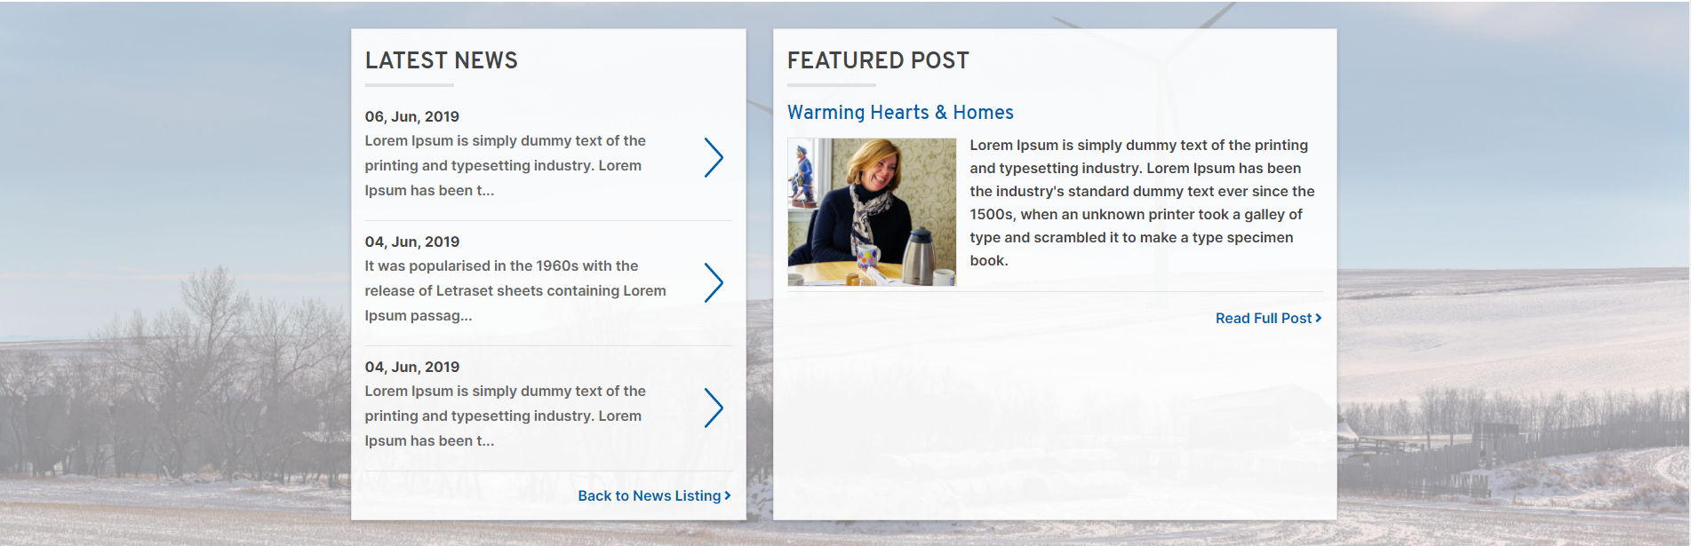
  - The background images for these layout/section widgets are populated by CSS classes, in this case the class “bg-imgDefault” is used
  - In the left section, add a “News” widget with the list template of “Latest News”
  - In the right section, add a “Featured Content” widget with content
- Homepage Hero – Home (/ or /home)
  - Add “Homepage Hero” widget to the top of the page
  - Fill out content fields on widget
  - Select the “Hero” widget template
- Landing Page Hero – FAQ (/faq)
  - Add “Homepage Hero” widget to the page
  - Fill out content fields
  - Select the “Hero.landing” widget template
  - To make it show up only with the primary link, select the “Hero.SingleButton” widget template
- Inner Page Hero – Thank You (/thank-you)
  - Add widget “Innerpage Hero” to the page
  - Fill out content fields
- Quick Links – Homepage (/ or /home) 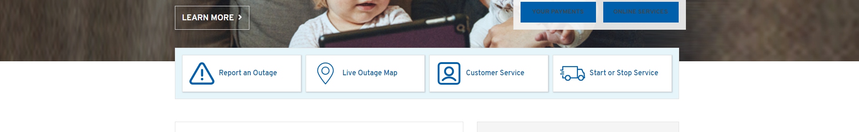
  - Adding quick links under hero with negative margin (like picture)
    - Add layout widget “quicklinks-layout” to the page
    - Add individual “QuickLinks” widget inside of that layout widget.
  - Adding quick links under hero or anywhere else with stand whitespace margin
    - Add layout widget “section” to the page and replace ‘container’ CSS class with ‘quicklinks’
    - Inside of that layout widget, add another layout widget “container” as is.
    - Inside of that container layout, add another layout widget “container” and replace the ‘container’ CSS class with ‘row wrapper’.
    - Add individual “QuickLinks” widget inside of that layout widget.
- Today’s Power/By The Numbers – Homepage (/ or /home)
  - Add layout widget “section” to the page. Recommended to add CSS ‘sectionPadding’to give space around section, but not necessary.
  - Inside of that layout, add layout widget “container”. Replace ‘container’ CSS class with ‘row’.
  - Add content widget “Todays Power” in previous layout widget
  - Add content widget “Content Block” to previous layout widget. Paste in raw source from the HTML editor from homepage example
- Infographic Widget – Outage Centre (/outage-centre)
  - Add content widget “Infographic Widget” to page
  - Fill in content fields
- Tabbed Content – Outage Centre (/outage-centre) 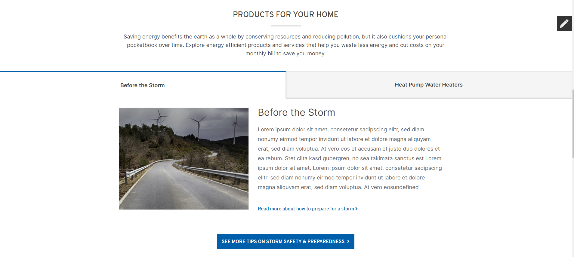
  - Add layout widget “tabbed-content-layout”
  - If applicable, you can add content widget “Section Title” to the title seciton of the layout widget
  - Add Individual “Tab” content widgets.
    - Adding “Tab” widgets will add the actual tabs to the page, so there is no separate widget for content and tab
  - There is a link section at the bottom of the layout that can be used to place a “Content Block” widget to add a link.
- Quick Info – Homepage (/ or /home) 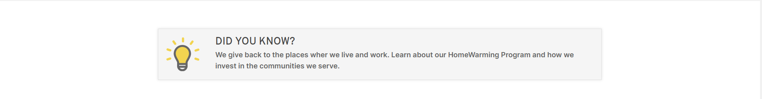
  - Add content widget “Quick Info” to page and fill out content fields
- Help Tiles – Outage Centre (/outage-centre) 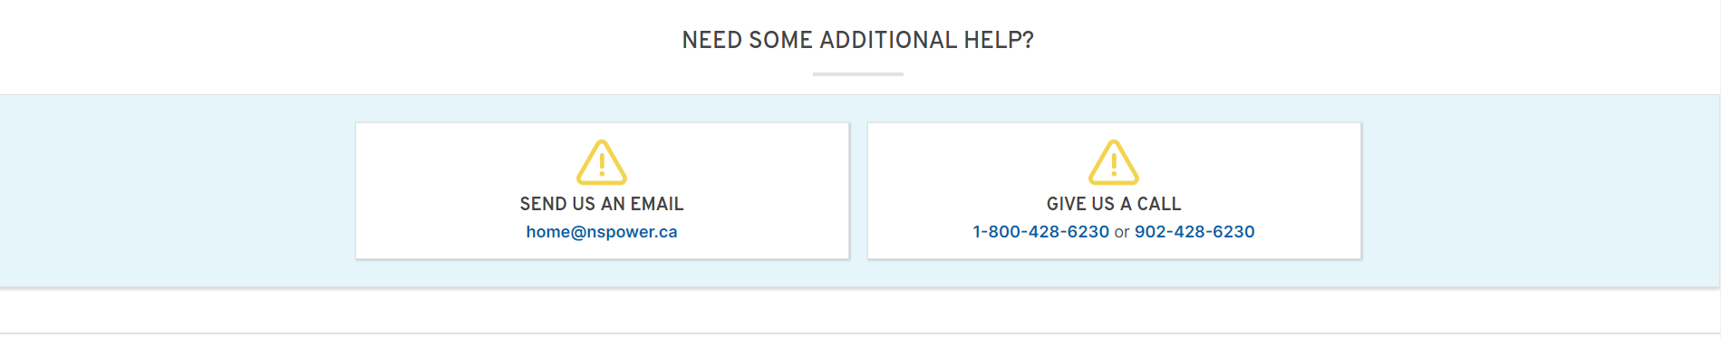
  - Add layout widget “help-tiles-layout” to the page
  - Layout has a section for “Section Title” widget if needed
  - Add individual “Help Title” content widgets to the layout.
- Steps Widget – Audience Landing (/audience-landing) 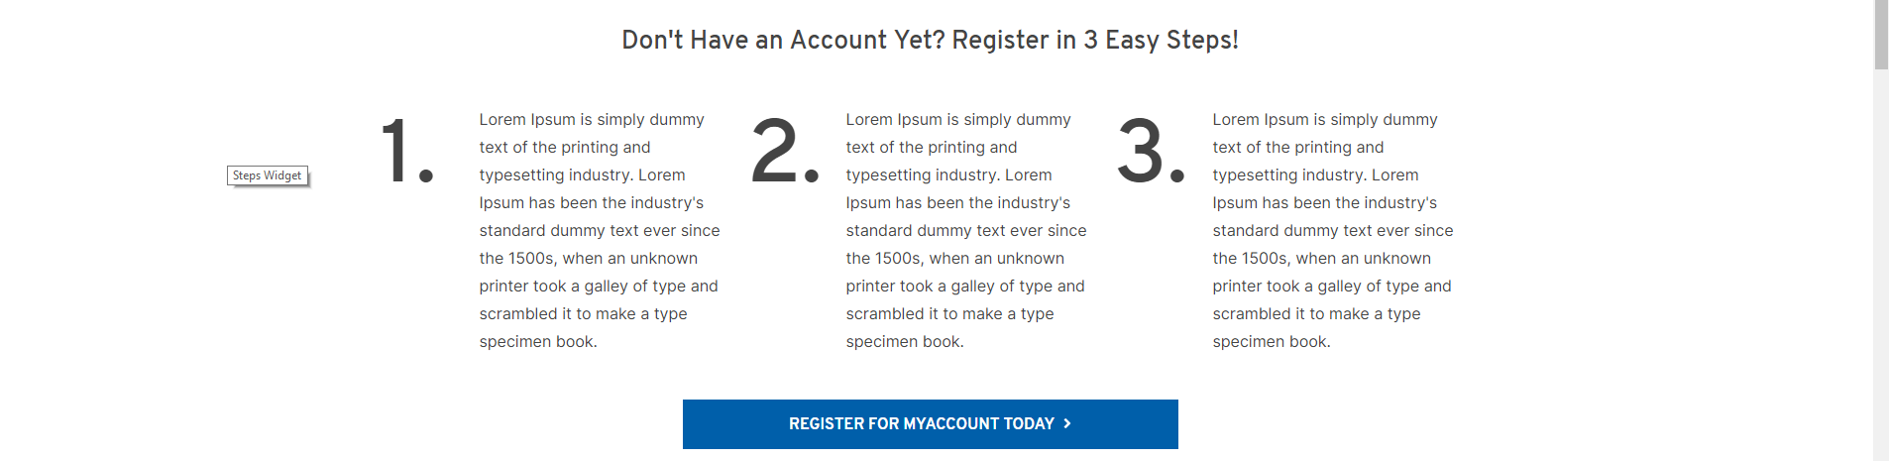
  - Add content widget “Step” to the page
  - Fill in content fields
- Listing Widget - Customer Service (/customer-service )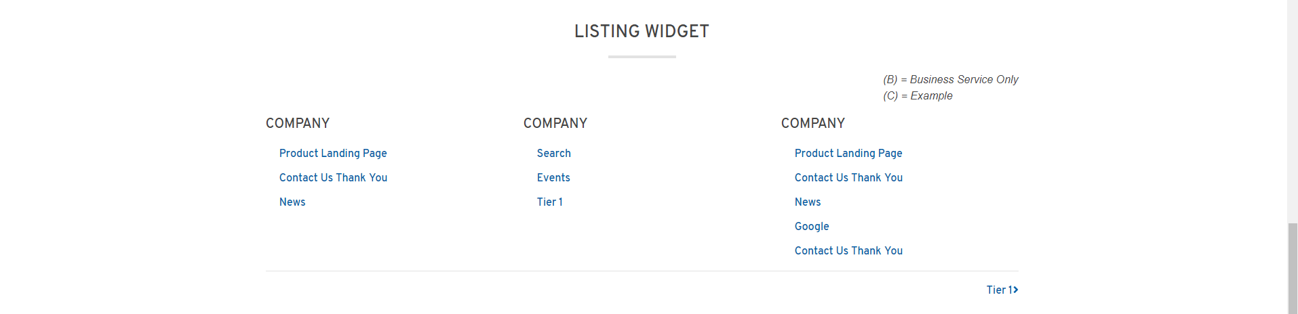
  - Add layout widget “section”
  - Layout can have “Section Title” widget added at the top
  - Inside section layout, add layout widget “listing-layout”
  - Layout has section for a Legend that you can put a “Content Block” widget into
  - Add individual “Listing” content widget inside of layout section for “Lists”
    - Each line break separates each item
  - Layout has a bottom section for a link that you can put a “Content Block” widget in
- Featured Videos (Side by Side) – Create or Manage Account (/create-manage-account) 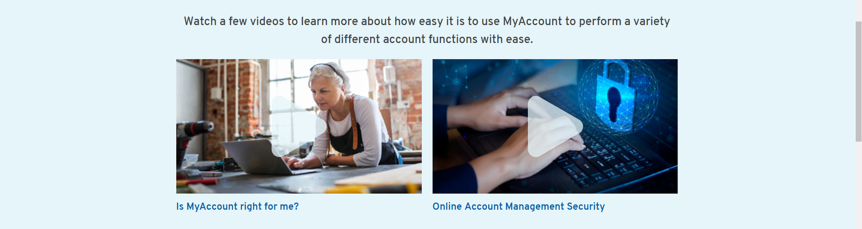
  - Add layout section “blue-background-layout” or “white-background-layout”
  - Add layout widget “two-column-featured-videos”
  - Content widget “Section Title” can be added to the title zone
  - Add individual “Featured Video/Image” content widgets. The image will be the thumbnail image

